Love and Money

Thurber and Oliver

## Data

The data in the **LoveAndMoney.TXT** file was collected by Shonda Kuiper. The variable ***Money*** represents the amount the individual spent last Valentine’s Day. The variable ***Love*** is a score on a satisfaction scale.

LoveMoney <- read.csv("LoveandMoney.csv")  
 head(LoveMoney)

## X Love MoneySpent  
## 1 1 0 25.0  
## 2 2 100 275.0  
## 3 3 0 26.0  
## 4 4 0 27.0  
## 5 5 2 33.0  
## 6 6 5 41.5

## Univariate Statistics

Plots and numeric descriptives of the individual variables are not particularly remarkable.

p_load(mosaic)  
 bwplot(~MoneySpent, data=LoveMoney)

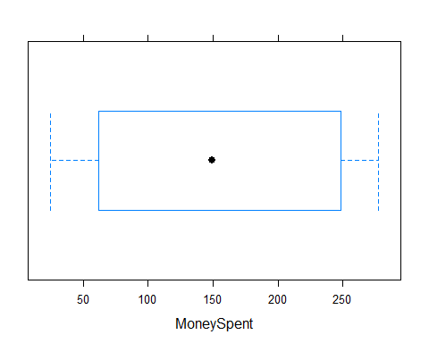

bwplot(~Love, data=LoveMoney)

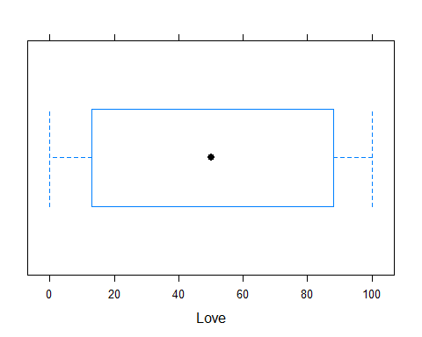

histogram(~MoneySpent, data=LoveMoney)

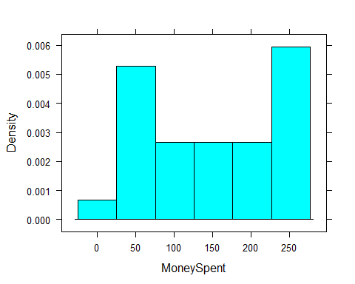

histogram(~Love, data=LoveMoney)

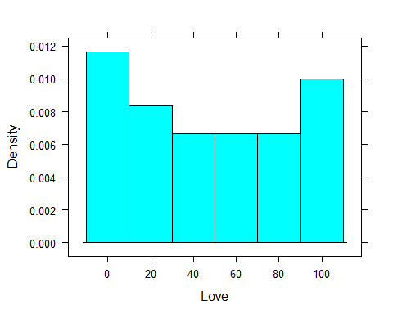

## Bivariate Analysis

A scatterplot of ***MoneySpent*** as a function of ***Love*** indicates that there may be a linear relationship between the two variables.

xyplot(MoneySpent~Love,LoveMoney,pch=16,cex=1.5)

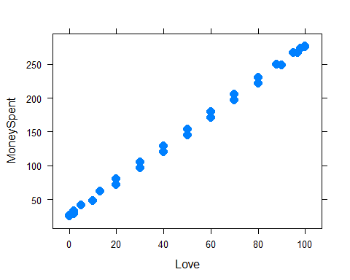

We fit the linear model.

LoveMoney.lm.l=lm(MoneySpent~Love,data=LoveMoney)  
 summary(LoveMoney.lm.l)

##   
## Call:  
## lm(formula = MoneySpent ~ Love, data = LoveMoney)  
##   
## Residuals:  
## Min 1Q Median 3Q Max   
## -5.9567 -2.9595 0.5433 3.2689 4.0476   
##   
## Coefficients:  
## Estimate Std. Error t value Pr(>|t|)   
## (Intercept) 25.94950 1.08919 23.82 <2e-16 ***  
## Love 2.50014 0.01761 141.99 <2e-16 ***  
## ---  
## Signif. codes: 0 '***' 0.001 '**' 0.01 '*' 0.05 '.' 0.1 ' ' 1  
##   
## Residual standard error: 3.512 on 28 degrees of freedom  
## Multiple R-squared: 0.9986, Adjusted R-squared: 0.9986   
## F-statistic: 2.016e+04 on 1 and 28 DF, p-value: < 2.2e-16

The resultant model supports the strong relationship that was seen in the scatterplot. We follow the fitting of the linear model with a quick look at the residuals.

xyplot(LoveMoney.lm.l$resid~LoveMoney$Love,col="red",pch=16,cex=2)

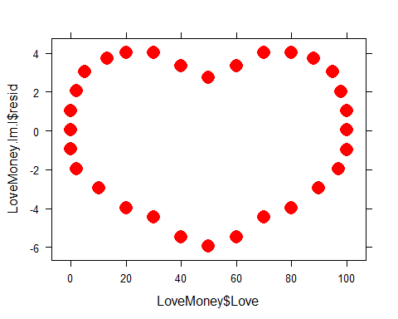

plot(LoveMoney.lm.l)

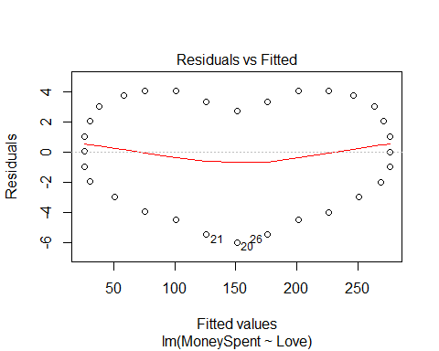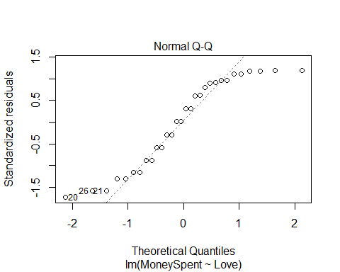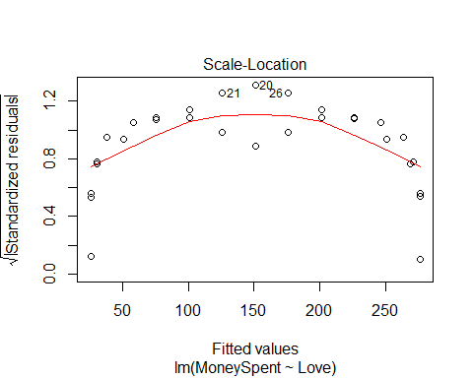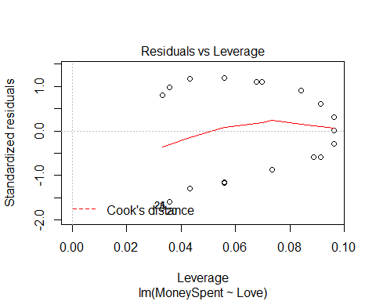

Just a little reminder that the patterns hidden within “linear” relationships are not always linear.